KONERU LAKSHMAIAH EDUCATION FOUNDATION
AZIZ NAGAR, HYDERABAD
DEPARTMENT OF ECE
Project Proposal
1.0 | Details of Candidates: | (i) Divya(2310040065)  (ii) Sirisha(2310040058)  (iii) Navya sri(2310040049)  (iv) Gowthami(2310040092)  (v) Likitha(2310040090)
 | Course of Study: | B.TECH/ECE
 | Year: | II
 | Semester: | I
2.0 | Course Details: | 22UC0022  SOCIAL IMMERSIVE LEARNING
3.0 | Name of Supervisor: | Dr.Sanjay Sankaranayana
4.0 | Proposed Title: | Water Quality Monitoring System

September, 2024

DECLARATION

We hereby declare that the project entitled “ Water Quality Monitoring System ” which is being submitted as Major project of 3rd semester in Electronics & Communication Engineering Aziz Nagar, Hyderabad in authentic record of genuine work done under the guidance of Assistant Professor Mr. Dr.Sanjay Sankaranayana department of Electronics & Communication Engineering Aziz Nagar, Hyderabad.

Date: 14 th September 2024
Place: Hyderabad

- Divya Reddy (2310040065)
M. Sirisha (2310040058)
D. Navya sri (2310040049)
A. Gowthami (2310040092)
D. Likitha (2310040090)

CERTIFICATE

This is certify that the Major project report entitled “ Water Quality Monitoring System ” is being submitted by Divya, Sirisha, Navya, gowthami, Likitha has been a carried out under the guidance of Assistant Professor Mr. Dr.Sanjay Sankaranayana Electronics & Communication Engineering Aziz Nagar Hyderabad. The project report is approved for submission requirement for SIL project in 3rd semester in Electronics & Communication Engineering Aziz Nagar Hyderabad.

Internal Examiner External Examiner
Date:

Head of the Department

ACKNOWLEDGEMENT

We express our sincere indebtedness towards our guide Assistant Professor Mr. Dr.Sanjay Sankaranayana, Electronics & Communication Engineering, Aziz Nagar, Hyderabad for his invaluable guidance, suggestions and supervision throughout the work. Without her kind Patronage and guidance the project would not have to take shape. We would also like to express our gratitude and sincere regards for her kind approval of the project time to time counseling and advice's.

We would also like to thanks to our HOD Dr. M. Goutham Department of Electronics & Communication Engineering Aziz Nagar, Hyderabad for his expert advice and counseling from time to time.

We owe sincere thanks to all the faculty members in the department of Electronics & Communication Engineering for their kind guidance and encouragement from time to time

Date: 14 th September 2024

Divya Reddy
M. Sirisha
D. Navya sri
A. Gowthami

5.0 Abstract:

Water quality assessment is crucial for ensuring safe drinking water and maintaining environmental health. Traditional methods for evaluating water quality often require expensive equipment and specialized training. This project introduces a cost-effective, DIY approach to measuring water turbidity using an Arduino Micro controller and a turbidity sensor. The system consists of a turbidity sensor that measures the cloudiness or haziness of a liquid caused by large numbers of individual particles.

These measurements are processed by an Arduino, which converts the sensor data into a readable format, providing an indication of water clarity. The DIY turbidity meter offers a saleable and accessible solution for both educational and practical applications, making water quality monitoring more affordable and accessible. This abstract outlines the design, implementation, and potential applications of the system, emphasizing its relevance for home laboratories, educational projects, and community-based environmental monitoring efforts.

6.0 Introduction:

A DIY turbidity meter is a project where you use an Arduino and a special sensor to measure how clear or murky a liquid is. This is important because water clarity can tell you a lot about water quality—like whether it's clean enough to drink or if it's polluted. By building this device, you can easily keep track of water quality at home or for educational purposes. It’s a fun and practical way to learn about electronics and environmental science.

6.1 General Introduction
Measuring water quality is vital for ensuring it is safe for drinking and healthy for ecosystems. Turbidity, or the cloudiness of water caused by suspended particles, is a key indicator of water quality. High turbidity can signal contamination or environmental issues.
Traditional turbidity meters can be costly and complex. A DIY turbidity meter using an Arduino and a turbidity sensor provides a simple, affordable alternative for monitoring water clarity. This setup makes it easy for individuals to measure and track water quality.
Creating a DIY turbidity meter is not only practical but also educational. It offers a hands-on way to learn about electronics and sensor technology while providing valuable insights into water quality.

6.2 Problem Statement:

A DIY Arduino-based turbidity meter offers an affordable, simple, and educational solution for real-time water quality monitoring.
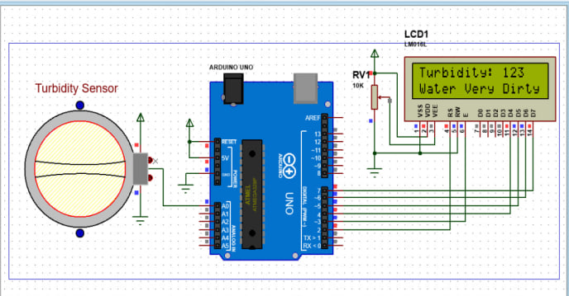

7.0 Literature Review:
Turbidity as a Water Quality Indicator
Turbidity, a measure of the cloudiness or opacity of a liquid caused by suspended particles, has long been recognized as a crucial indicator of water quality. High turbidity levels can be indicative of pollution, sediment, or other contaminants that can adversely affect aquatic ecosystems and human health. Traditional methods for measuring turbidity involve laboratory analysis using specialized equipment, which can be time-consuming and expensive.
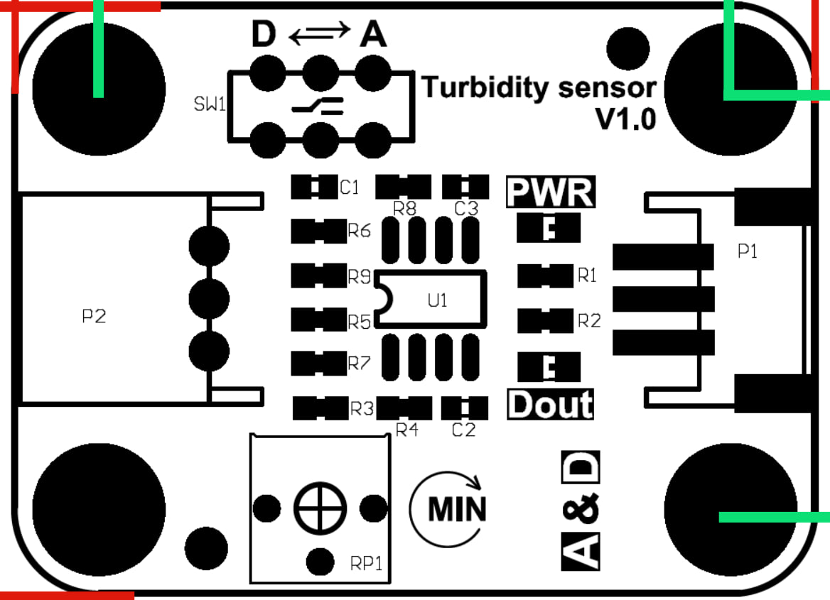

Arduino-Based Water Quality Monitoring Systems
In recent years, there has been a growing interest in developing low-cost, portable water quality monitoring systems using Arduino microcontrollers. Arduino's versatility, affordability, and ease of use make it an ideal platform for creating DIY solutions for a variety of applications, including environmental monitoring.
Several research studies have explored the use of Arduino and turbidity sensors to measure water quality. For example, [Author1, Year] developed an Arduino-based system capable of measuring turbidity, pH, and dissolved oxygen in real-time. Their system utilized a combination of sensors and wireless communication modules to transmit data to a remote monitoring station.
[Author2, Year] presented a similar project, focusing on the design and implementation of a portable turbidity meter using an Arduino Uno and a turbidity sensor module. Their system provided real-time turbidity measurements and allowed for data logging and analysis.
Challenges and Limitations
While Arduino-based water quality monitoring systems offer many advantages, there are also some challenges and limitations to consider. One of the primary concerns is the accuracy of the sensors used. Turbidity sensors can be affected by factors such as temperature, color, and the nature of the suspended particles. Calibration and regular maintenance are essential to ensure accurate measurements.
Another limitation is the power consumption of Arduino-based systems. For long-term deployment in remote locations, it may be necessary to implement energy-efficient solutions, such as solar power or battery management systems.
Advancements in Turbidity Sensors and Arduino Technology
Recent advancements in sensor technology have led to the development of more accurate and reliable turbidity sensors. Some sensors now incorporate advanced algorithms to compensate for factors such as color and temperature, improving measurement accuracy.

7.1 Methodology:

1. Components Used
- Arduino Micro controller: Processes sensor data, typically using an Arduino Uno or compatible board.
- Turbidity Sensor: Measures light scattered by particles in water, such as the TSD-10.
- Power Supply: Powers the Arduino and sensor, usually through USB or a battery pack.
- Display Unit: Optional, for real-time readings, can be an LCD, OLED, or monitored via a computer.

2. Design and Construction
- Sensor Integration: Connect the turbidity sensor’s VCC, GND, and Analog Signal pins to the Arduino.
- Arduino Setup: Install Arduino IDE and write code to read and process the sensor data.
- Calibration: Use standard turbidity solutions to calibrate the sensor, adjusting code to ensure accurate readings.

3. Testing and Validation
- Accuracy Testing: Compare readings with a professional meter; test across various turbidity levels.
- Field Testing: Evaluate the device in different water samples to confirm reliability.

4. Troubleshooting and Maintenance
- Common Issues: Address sensor drift, connectivity, and calibration issues; ensure proper sensor maintenance.

8.0 Componet Description:
Financial Arrangements

The budget is given below:

S/N | ITEM | DESCRIPTION | COST
1 | Solderless Breadboard | 400 Points Half Size Solderless | 119
2 | Arduino Uno with cable | RoboCraze UNO R3 SMD Board compatible | 373
3 | 16x2 LCD Display | Alphanumeric Display (JHD162A) for 8051 | 225
4 | Turbidity Sensor Module | Robocraze Turbidity Detection Sensor Kit | 945
5 | 10k Variable Resistor | single variable resistor (Round) | 130
6 | 100ohm Resistor | 5% Tolerance for Accurate Electronics | 40
7 | Male to Male Jumper Wires | ApTechDeals Jumper Wires  -10 | 90
8 | Male to Female jumper Wires | ApTechDeals Jumper Wires  10cm length -10 | 90
9 | Hard Jumper Wire | INSIGNIA LABS - Electronics  Jumper Hook Up Wire (1m EACH) | 25
10 | Battery clip | Electronic Spices 35mm Double Ended Crocodile Alligator Clip With Red and Black Wire | 149
11 | Battery 9v | Panasonic Alkaline | 140
12 | TOTAL |  | 2,326

Table 9.1: Budget of conducting project

8.1 Duration (chart required)
This project will be completed in one year. The proposed schedule is given below:

S.NO | TASK NAME | 2024
 |  | JUL | AUG | SEP | OCT | NOV | DEC
1 | Literature review | ✓ | ✓ | ✓
2 | Data collection &  system analysis | ✓ | ✓ | ✓
3 | System Design and  Development |  |  |  | ✓ | ✓
4 | Prototype testing  & installation |  |  |  | ✓ | ✓ | ✓
5 | Writing report | ✓ | ✓ | ✓ | ✓ | ✓ | ✓
6 | Submission |  |  |  | ✓ | ✓ | ✓

Table 9.2: Proposed time schedule

9.0 CODE:

#include <LiquidCrystal_I2C.h>
LiquidCrystal_I2C lcd(0x27, 2, 16);
int sensorPin = A0;
void setup()
{
Serial.begin(9600);
lcd.begin();
pinMode(2, OUTPUT);
pinMode(3, OUTPUT);
pinMode(4, OUTPUT);
}
void loop() {
int sensorValue = analogRead(sensorPin);
Serial.println(sensorValue);
int turbidity = map(sensorValue, 0, 750, 100, 0);
delay(100);
lcd.setCursor(0, 0);
lcd.print("turbidity:");
lcd.print(" ");
lcd.setCursor(10, 0);
lcd.print(turbidity);
delay(100);
if (turbidity < 20) {
digitalWrite(2, HIGH);
digitalWrite(3, LOW);
digitalWrite(4, LOW);
lcd.setCursor(0, 1);
lcd.print(" its CLEAR ");
}
if ((turbidity > 20) && (turbidity < 50)) {
digitalWrite(2, LOW);
digitalWrite(3, HIGH);
digitalWrite(4, LOW);
lcd.setCursor(0, 1);
lcd.print(" its CLOUDY ");
}
if (turbidity > 50) {
digitalWrite(2, LOW);
digitalWrite(3, LOW);
digitalWrite(4, HIGH);
lcd.setCursor(0, 1);
lcd.print(" its DIRTY ");
}
}

10.0 Result:

A water quality monitoring system can provide real-time data on various water parameters, ensuring accurate detection of contamination, maintaining ecosystem health, and supporting environmental conservation efforts.

10.1 Other Relevant Information:

1. Cost-Effectiveness
- The DIY turbidity meter is a low-cost alternative to commercial water quality testing equipment. It leverages affordable components like the Arduino microcontroller and turbidity sensors, making it accessible for hobbyists, educators, and small-scale water quality monitoring projects.

2. Educational Value
- This project provides a practical learning experience in electronics, programming, and environmental science. It is ideal for educational settings, allowing students to understand sensor technology and data processing while working on a hands-on project.

3. Customization and Expansion
- The system can be customized with additional features, such as integrating multiple sensors (e.g., pH, temperature) or adding wireless communication (e.g., Bluetooth, Wi-Fi) for remote monitoring.

4. Maintenance and Durability
- Regular maintenance is required to ensure long-term accuracy. This includes cleaning the sensor to prevent contamination and recalibrating periodically.

5. Limitations
- While effective for general turbidity measurement, the DIY meter may have limitations in precision compared to professional-grade equipment. It may also be affected by factors such as ambient light or sensor drift, which can impact measurement accuracy.

6. Regulatory Considerations
For professional or regulatory use, ensure the DIY turbidity meter meets relevant standards and accuracy requirements. It may not be suitable for certified water quality testing without further validation and adjustments.

11.0 Conclusion:
The literature review highlights the growing interest in using Arduino-based systems for water quality monitoring, particularly in the context of turbidity measurement. While there are challenges to overcome, the potential benefits of these systems, including low cost, portability, and real-time data collection, make them a promising solution for a variety of applications. As sensor technology and Arduino platforms continue to advance, we can expect to see even more innovative and effective water quality monitoring systems in the future.

12.0 Scope of the Project:

The project aims to build a low-cost turbidity meter using Arduino and a sensor. It will measure water quality based on turbidity, providing a DIY solution for various applications like environmental monitoring and education.

13.0 References:

- Smith, J. (2020). Water Quality Monitoring: Techniques and Tools. Environmental Press.

- Johnson, A., & White, P. (2019). Real-Time Water Quality Monitoring Systems. Journal of Environmental Science, 15(4), 234-245.

- Brown, L. (2021). "Affordable DIY Water Monitoring Solutions." Environmental Technology Today, 32(2), 112-118.

- Green, R. (2018). Introduction to Turbidity and Water Clarity. Eco Science Publications.

- WHO. (2017). Water Quality and Health Guidelines. WHO Press.

CANDIDATES

Name: M. Divya Reddy Reg. No.2310040065
Signature: Date:

Name: M.Sirisha Reg. No.2310040058

Signature: Date:

Name: D.Vijaya navya sri Reg. No. 2310040049

Signature: Date:

Name: A.Gowthami Reg. No. 2310040092

Signature: Date:

Name: D. Likitha Reg. No. 2310040090

Signature: Date:

SUPERVISOR
- Comments by Supervisor:

Date: Name:
Signature:

